River Data

The main focus of our visualization is to clearly identify pools and riffles while minimizing noise in the data. Our secondary goal is to be able to identify symmetry between the pools and riffles. We are able to switch between all the river data given to us.

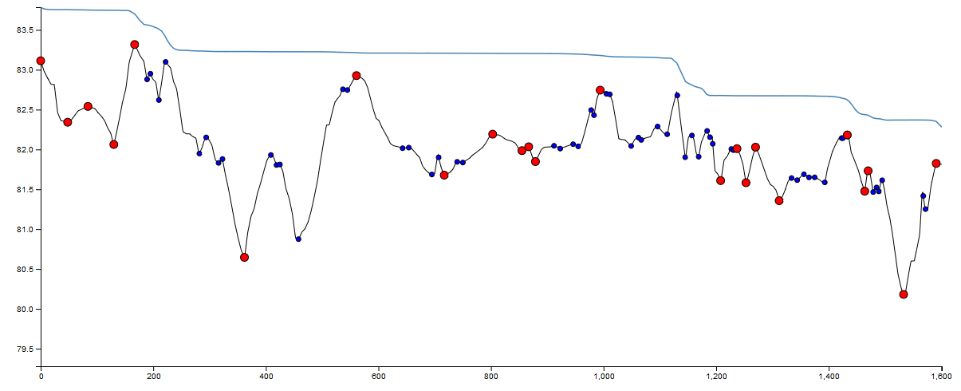

The above figure shows the different pools and riffles in a river. We decided to use a trendline to identify the pools and riffles while ignoring other peaks that may appear. Basically, we alternated between points above and below the trendline. These points are the bigger red circles on the line. We also decided to include all other peaks which are the smaller blue circles. The reasoning behind this because the trendline algorithm may ignore points that might be considered a pool or a riffle. By having both points on the graph, it is much easier to compare where the trendline failed or succeeded to include what we want to see.

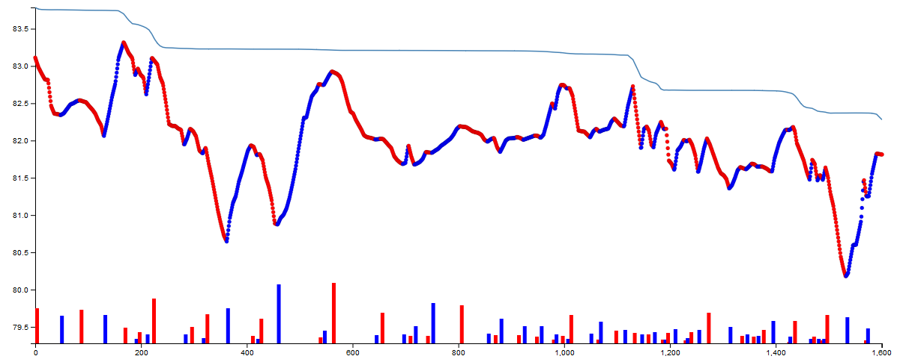

The above shows the different rising and falling slopes in the river. The goal of this visualization is to be able to identify asymmetry. The red is wherever the river has a falling slope, and the blue is wherever the river rises. The bars on the bottom are the length of the slopes. The goal here is to compare the two pairs of blue and red lines at the bottom to check length difference. The idea is if the bars at the bottom are similar lengths, then they are more symmetrical which you can easily confirm by looking at the above line graph. Each bar is also located at the start of where the line rises or falls, so that you easily identify which part of the line it symbolizes.